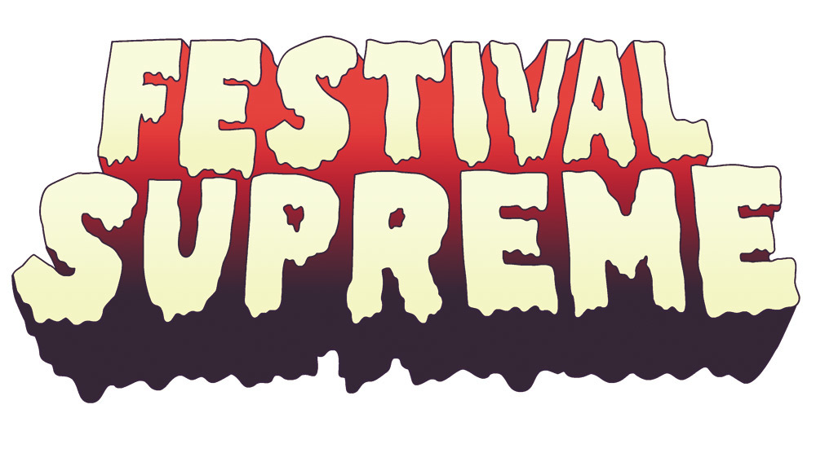
TENACIOUS D ANNOUNCES STACKED FESTIVAL SUPREME LINEUP

MUSIC AND COMEDY FESTIVAL TO TAKE PLACE
SATURDAY, OCTOBER 25TH
AT LA SPORTS ARENA & EXPOSITION PARK

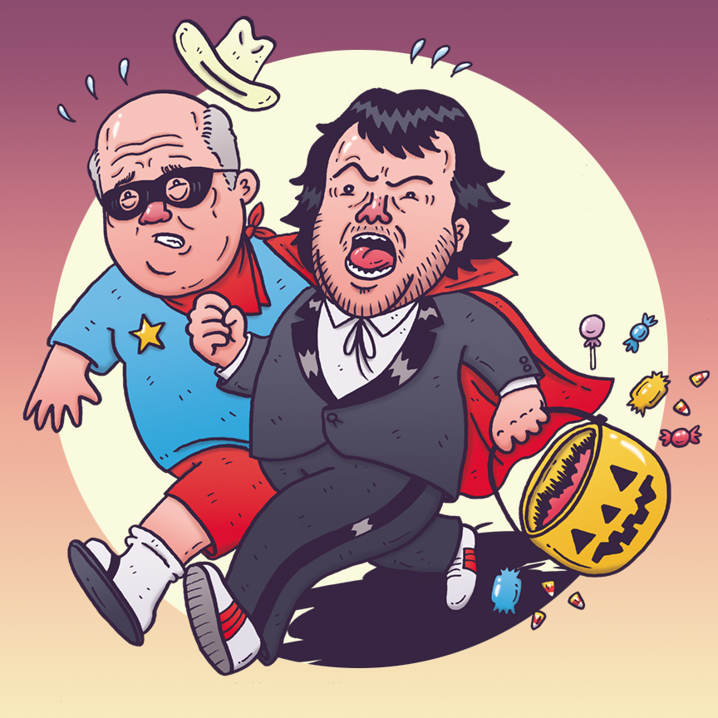

(May 27, 2014 – Los Angeles, CA) Tenacious D, the Greatest Band in the World, is tickled to announce the incredible lineup for Festival Supreme 2014. This year’s one-day extravaganza includes 40 of today’s most talented musicians and comedians who will take the stage alongside a Circus of Death (gory details to be revealed soon)! The bigger, better, even more supreme affair will be held at the LA Sports Arena and Exposition Park in downtown Los Angeles on October 25, 2014.

"Here it is, the good times line up you were promised. Put that in your pipe and smoke it!" said Tenacious D.

General admission tickets for the spooky extravaganza are $99 (plus fees). VIP tickets are $250 and will include VIP express entry, VIP viewing at each stage and tent, a VIP Lounge featuring shaded areas, extra restrooms, food and beverage vendors and a cash bar along with a commemorative laminate. Tickets will go on sale on Friday, May 30th at 10:00am PST via FrontGate Tickets at festivalsupreme.frontgatetickets.com. Festival Supreme is an age 17+ event.

2013’s Festival Supreme sold out in advance at the Santa Monica Pier, showcasing the comedy and musical stylings of favorites including Adam Sandler, The Mighty Boosh, The Mr. Show Experience, Triumph the Insult Comic Dog, Reggie Watts plus a spectacular special guest appearance by The Lonely Island during Tenacious D’s spectacular finale.

FESTIVAL SUPREME 2014 LINEUP

Dethklok Metalocalypse
Cheech & Chong
Workaholics
Margaret Cho
The State
Fred Armisen & Bill Hader
Nick Kroll
Peaches
Drunk History
Norm Macdonald
Janeane Garofalo
Comedy Bang! Bang! starring Scott Aukerman
Maria Bamford
T.J. Miller
Kumail Nanjiani
Eagles of Death Metal
Jenny Slate
Dr. Demento
Doug Benson
Heidecker & Wood
Natasha Leggero
Bo Burnham
The Dan Band
Mary Lynn Rajskub
The Aquabats
DJ Lance Rock
Eric Andre
Bridget Everett
The Protomen
Ron Lynch
Jerrod Carmichael
Nick Thune
Arj Barker
The Tulsa Skull Swingers
Rob Zabrecky
The Upper Crust
Awkwafina
The Kyle Gass Band
The Haden Triplets
Tenacious D

Fans can visit www.festivalsupreme.com to stay updated on all things Festival Supreme.

Festival Supreme 2014 is produced by Tenacious D and Goldenvoice.

www.facebook.com/festivalsupreme
www.twitter.com/festivalsupreme
www.instagram.com/festivalsupreme
http://fuckyeahfestivalsupreme.tumblr.com/

Media Contact:
Fresh and Clean Media / 310.313.7200
Brittany Pearce / Brittany@freshcleanmedia.com
Sandee Fenton / Sandee@freshcleanmedia.com

